**Road Accident Avoiding System Using Intelligent Speed Lock Technique**

1**Virinchi Kaushik**,**2Md. Sadiq Afreed Meeran**,**3A Prasanna**,**4Praveen Kumar V K**,5**Paras**

1,2,3,4Department of CSE, 5 Department of ECE, BITM, Ballari, Karanataka, India

1. **PROBLEM STATEMENT:**

**To design a device that reduces the number of road accidents using IOT (Internet of Things) in four-wheeler vehicles**

1. **Abstract:**

**Now day’s accidents are taking place at large scale. Majority of the accidents occurs due to the over speeding of vehicles, though there are speed limiting boards placed at the roadside of highways also at the road side in the city. But none of vehicles (drivers) follows the speed mentioned in the speed limit boards, due to which accidents occurs. To overcome such over speeding of vehicle problem we have come up with system which intelligently controls/slowdown the speed of the vehicle and locks the speed to that specified speed mentioned in the speed limit boards. Even if the driver tries to accelerate he ca­­nnot accelerate it. Since speed of the vehicle has been locked by the proposed system. This proposed system consists of central server which dynamically keeps monitoring the weather information of different cities and sends these data to respective cities local servers. These local server in turn depending upon the weather information received, manipulates the speed limit to be set (it might be for either highway or in the city) and sends the speed limit information to the digitalized speed limit boards which consists of the device (device kept at roadside) which accepts the information of the speed limit and the device consists of high range router, it keeps on sending the speed limit information to all the vehicles using MQTT protocol. Whenever a vehicle comes into the routers range the system(device) which is placed in every vehicle, gets activate the wifi and gets connected with the external device(kept at road side via router) which has send the speed limit information through MQTT protocol. Then the processor of the device kept inside the car reads the current speed of the vehicle and compares with the information of speed received, if the speed of vehicle is greater than received speed limit information then the pressure at the accelerator is released slowly by a device which is kept at the pivot of gas pedal to make the vehicle comes down to the speed specified by the speed limit boards. So by this proposed system the accidents rate can be minimized to larger extent just by making the vehicle function intelligently all this is possible only by the proposed system is installed in the vehicle. This device (proposed system) is not to be installed in the emergency vehicles like ambulance and fire engine vehicles so that there should not be any speed limit restrictions for these emergency vehicles.**

1. **INTRODUCTION:**

**Many precious lives are lost due to road accidents due to over speeding every day. It is an important concern for departments that deal with road safety and for the citizens. Road traffic data must be critically analyzed to determine the factors that are closely related to road accidents. Places near residential areas, zebra crossing, school regions are the major zone of accidents. The number of road crash deaths has increased by 31% from 2007 to 2017**. **As per the survey on the road accidents in India, according to the Ministry of Road Transport and Highways, 1,50,785 people were killed and another 4,94,624 were injured in 4,80,652 road crashes in India in 2016. This translates into 1317 crashes and 413 deaths every day or 55 crashes and 17 deaths every hour. The number of road crash deaths has increased by 31% from 2007 to 2017 and that of fatal road crashes have increased by 25.6% in the same period. Four-wheelers like cars, jeeps and taxis accounted the share of road crashes with (1,13,267) contributing 23.6% and trucks, tempos, tractors and other articulated vehicles (1,01,085) contributing 21.0% and buses (37,487) contributing 7.8% to total road crash fatalities. So, we are developing a system which controls the accidents in accident prone areas based on IOT(Internet of Things).**

1. **PROPOSED SYSTEM:**

**The proposed system consists of the main display unit which displays the following attributes:**

1. **Sensor number: It tells ID of the sensor from which the protocol has been received.**
2. **Present location: Gives the present longitude and latitude of the vehicle.**
3. **Present Speed limit: Displays the maximum current speed limit for the vehicle up to which it can accelerate.**
4. **Present load: It displays the current load of the vehicle.**
5. **Owner Info: It displays the vehicle owner.**

**Processor: The proposed system is designed using Raspberry pie which is a device consists of an inbuilt processor with the clock speed of 700mhz**

**Storage: Storage module consists of the static table having the fields such as inbuilt speed limit when there is no internet, longitudinal and latitudinal speed limit. Processor constantly checks the information from GPS then it compares the longitude, latitude information in the table fields and matches with the desired speed limit.**

**Communication unit: Dynamic display boards act as a communicating unit in the proposed system which consists of a very high range WIFI router which sends the protocols (with the speed limit data) to the vehicles which passes the communicating unit**

**Pressure sensor: This sensor is controlled by the processor to release/reduce the pressure of the accelerator in the vehicles as per the protocol (with speed limit data) received from the dynamic display boards.**

1. **WORKING SCENARIOS OF THE PROPOSED SYSTEM:**

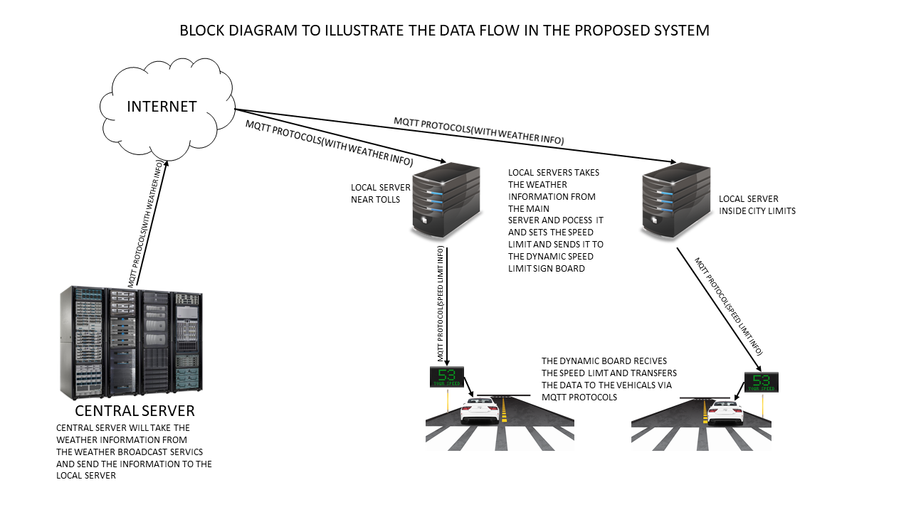

**The proposed system consists of a main or central server and the local servers which are located near the toll’s and inside the city limits near headquarters of that city. The central server first collects the information from the weather broadcast services about the weather information at different places. After receiving the data from the weather broadcast services, central server sends the information to that location’s local server via MQTT (Message Queue Telemetry Transport) protocol. As soon as the local servers get the information about the weather it starts processing and sets the exact speed limit for that weather condition and passes the processed information from the local server to the dynamic speed limit board via MQTT protocols. Dynamic speed limit board consists of a high range WI-FI router which shares the internet for a longer range, a device is fixed inside the vehicles where the WIFI receiver is present as the car reaches the WIFI zone it gets automatically connected with the dynamic speed board where the protocol is transferred between the dynamic board and the vehicle about the information on speed limit. As the protocol (with the speed limit data) is received by the vehicle now the processor which is present in the vehicle starts processing the protocol and simultaneously it gets the information from the speedometer and the pressure sensor present in between the gas pedal and pivot. Now the processor sends the signals to the pressure sensor to reduce or increase the pressure that is need be applied on the gas pedal as the pressure decreases the speed of the vehicle decreases so that the vehicle is made to run according to the speed limit. By using the proposed system, we can minimize the level of accidents that are occurring due to over speeding.**

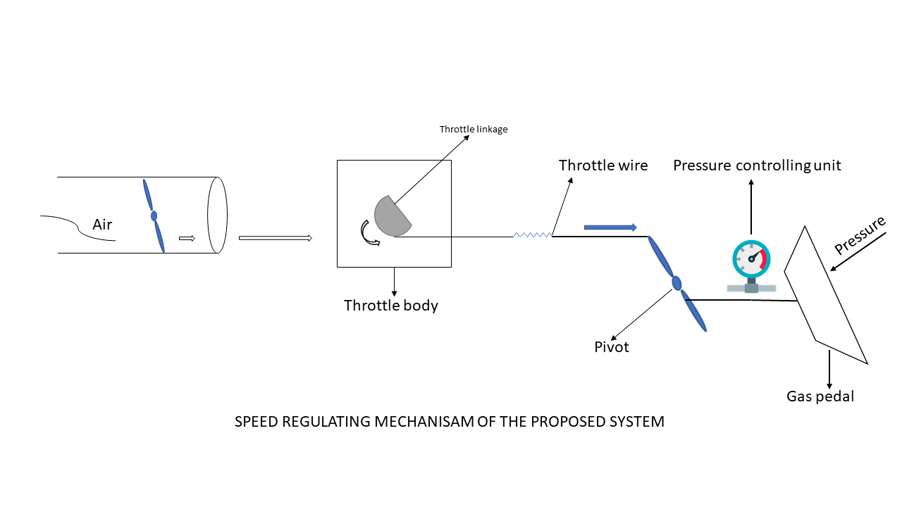

1. **HARDWARE AND SOFTWARE COMPONENTS:**

**These are the following components used in the proposed system in order to reduce speed of the vehicle and speed lock it automatically**

**HARDWARE COMPONENTS:**

1. **WIFI router**
2. **Electro-magnetic sensors**
3. **Pressure control unit**
4. **GPS module**
5. **DC geared motors**
6. **SOFTWARE COMPONENTS:**

**The following software’s are used to make all the Hardware components functional**

1. **Raspbian, ubuntu mate, windows IoT**
2. **PYTHON3**
3. **REFERENCES:**
4. **Road crash statistics 2016 by ministry Road Transport and Highways**
5. [**https://sites.ndtv.com/roadsafety/important-feature-to-you-in-your-car-5/**](https://sites.ndtv.com/roadsafety/important-feature-to-you-in-your-car-5/)
6. **Design of Auto wakeup Alarming System For Commuters in Railway Sleeper Coaches**